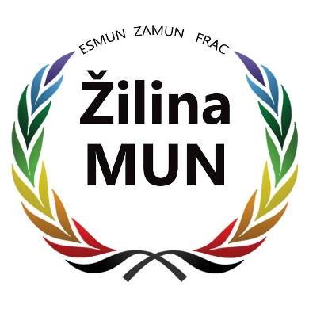

STUDY GUIDE

UNITED NATIONS
HUMAN RIGHTS COUNCIL
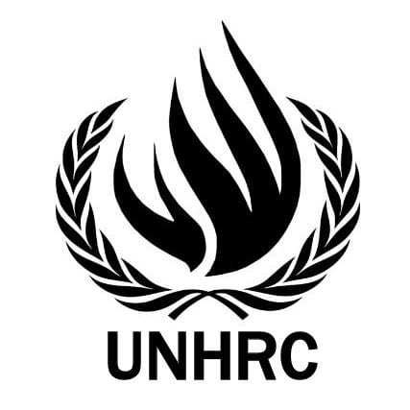

Topic: Forced displacement due to climate change

Karolína Filičková ZAMUN 2020

Contents

Word of Welcome from your Chair 3
Introduction to the committee 4
Introduction to the topic 5
Definition of key terms 6
Global overview to the topic 7
Most affected areas 8
Effects of climate change .10
Internal vs Cross-Border displacement 12
Past action 13
Leading questions 14
Useful video links 15
Bibliography 15

Word of Welcome
from your Chair

Dear delegates,
It is my absolute pleasure and honour to welcome you to the ZAMUN 2020 Human Rights council.
During your 3 days experience at ZAMUN it will be my privilege to be your committee Chair and I will do my best to facilitate the debate, create a productive working environment and provide you with the useful information in this Study Guide.
Having attended several MUN conferences in many European countries, I know that each MUN has its own rules that may differ. Therefore, if this will be your first time at ZAMUN, I would strongly recommend you to read carefully the Rules of Procedure (you can find them on the website). Nevertheless, making mistakes is natural and asking questions more than welcome, so you don’t have too feel stressed about anything.
The topic you will be discussing during the committee sessions will be the Forced displacement due to climate change. It is an issue of global significance that has tendency to grow fast if effective measures won´t be taken in a short scale of time,
As you will be brought up against challenging questions, the thoroughgoing research is essential to be able to face them. This Study Guide will provide you with a good basis, however, the additional research is necessary. I hope that you will use the acquired knowledge during your discussions, represent your country authentically and we will all enjoy fruitful debate proposing many great solutions.
Lastly, I believe that during this MUN you will not only learn how the UN works and how good resolution should be written, but you will also get to know people from various countries, make some new friendships and experience the local atmosphere. You already took the chance, so try to take the most out of it.
In case you have any questions about anything that comes to your mind, do not hesitate to contact me.
I am looking forward to meeting you all.
Yours sincerely,
Karolína Filičková.

Introduction to the committee

The Human Rights Council is an inter-governmental body within the United Nations system responsible for strengthening the promotion and protection of human rights around the globe and for addressing situations of human rights violations and make recommendations on them. It has the ability to discuss all thematic human rights issues and situations that require its attention throughout the year. The Human Rights Council replaced the former United Nations Commission on Human Rights.
Brief History
- DECEMBER 2004 - “High-level Panel on Threats, Challenges and Change“ recommends strengthening the UN Commission on Human Rights
- MARCH 2005 - UN Secretary-General Kofi Annan recommends to replace the Commission with a “Human Rights Council”
- 15 MARCH 2006 - The Council replaces the Commission on Human Rights by UN General Assembly res. 60/251 18
- 30 JUNE 2006 - The Council holds its 1st session in Geneva
The Human Rights Council meets for at least 10 weeks per year at the UN Office at Geneva. It can also convene urgent meetings on short notice to respond to emerging human rights crises.
The Council is made up of 47 United Nations Member States which are elected by the UN General Assembly. Council membership is based on equitable geographical distribution of seats in order to reflect the UN’s diversity, and thus give it legitimacy when speaking out on human rights violations in all countries.
Among the Council’s subsidiary bodies are the Universal Periodic Review mechanism, which is a unique process involving a review of the human rights records of UN member States, the Advisory Committee, which functions as the “think-tank” of the Council focusing mainly on studies and research-based advice, and the Complaint Procedure, which brings human right violations to the attention of the Council and is based on communication received from individuals, groups or non-governmental organizations.
The UN Special Procedures also serves as a complementary body to the UN Human Rights Council. It is made up of special rapporteurs, independent experts or working groups who are appointed by the Council and undertake country visits in order to examine, advise, publicly report and alert the international community to certain human rights issues.
Introduction to the
topic

Climate change is clearly one of the largest challenges facing our planet in the 21st century and things that we depend upon and value, such as water, energy, agriculture, ecosystems, or human health are experiencing the effects of a changing climate.
In 1990, the Intergovernmental Panel on Climate Change noted that the greatest single impact of climate change could be on human migration—with millions of people displaced by shoreline erosion, coastal flooding and agricultural disruption. Nowadays, various reports are confirming the climate change as a major driver of population displacement. According to Internal Displacement Monitoring Centre, weather-related hazards triggered in 2017 the vast majority of the new displacements, mostly in the East and South Asia, America and the Pacific area. But unfortunately, just as the phenomenon of climate change was ignored for many years in despite of experts’ warnings, the migration due to environmental degradation is also still not recognized as a fundamental human right issue and people displaced by climate don’t have refugee status.
The Office of the United Nations High Commissioner for Human Rights highlights the obligations and responsibilities of States and other duty-bearers to address the human mobility challenges created by climate change. States must ensure that any measure or legislation that governs or affects migration is consistent with their human rights law obligations and does not adversely affect the full enjoyment of the human rights of migrants or IDPs.

Definition of key
terms

Forced displacement
- refers to a situation of persons who have to leave or flee their home due to conflict, violence, environmental disasters or other peril in order to search for security and livelihoods

Internally Displaced Persons (IDPs)
- persons or groups of persons who have been forced or obliged to flee or to leave their homes or places of habitual residence, in particular as a result of or in order to avoid the effects of armed conflict, situations of generalized violence, violations of human rights or natural or human-made disasters, and who have not crossed an internationally recognized State border (Guiding Principles on Internal Displacement, 1998)

Climate / Environmental refugee
- term, that refers to a person migrating due to climate change impacts. It is often used in media, however, this term does not exist in an international law

Nexus Dynamics
- forced relocation due to adverse effects of climate change and disasters that correlate with armed conflicts

Planned relocation
- refers to re-building of livelihoods for those persons whose previous livelihoods have been destroyed as a result of an environmental degradation and/or disaster; with making provision for the human rights of both relocated persons and receiving communities and preserving their previous living standards

Global overview to
the topic

Climate has always been a major driver of human migration. People looking for better living conditions were able to move even from one continent to another. What we observe today, though is not a voluntary decision of people to leave their residence. In some areas of the world, the retrograding natural conditions and climate related disasters are creating a hostile environment, in which life is almost impossible and people are forced to migrate.
Across the globe, the climate change is already having severe impacts on the health and welfare of all people. This crisis leaves no country and no person untouched. For those on the frontlines, the impacts are particularly severe. Access to food, water and sanitation, adequate housing, health, and decent work – all fundamental human rights – are being eroded. In many cases, lives are at risk.
According to the Office of the United Nations High Commissioner for Refugees, the likelihood of being displaced due to climate change and natural disaster has more than doubled since 1970, with an estimated 203.4 million people displaced between 2008 and 2015.
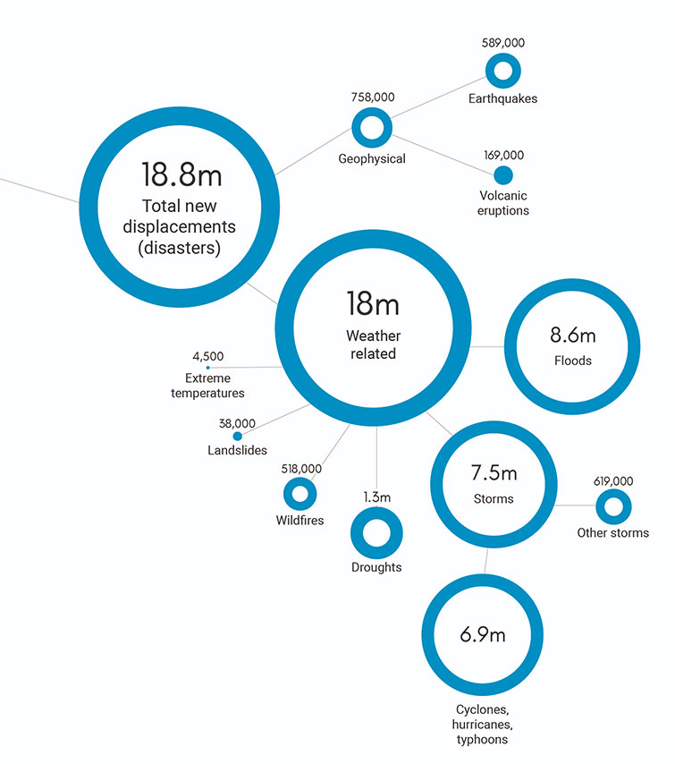
In 2018, 17.2 million people in 144 countries and territories were newly displaced in the context of disasters within their own country and the first half of 2019 saw 7 million new internal displacements due to disaster.
The alarming fact is that the majority among these numbers of displaced persons has contributed the least to the drivers of climate change, yet they are at the front lines of its unforgiving impacts.

Most common weather-related causes of internal displacement monitored in 2017 by Internal Displacement Monitoring Centre

Most affected areas

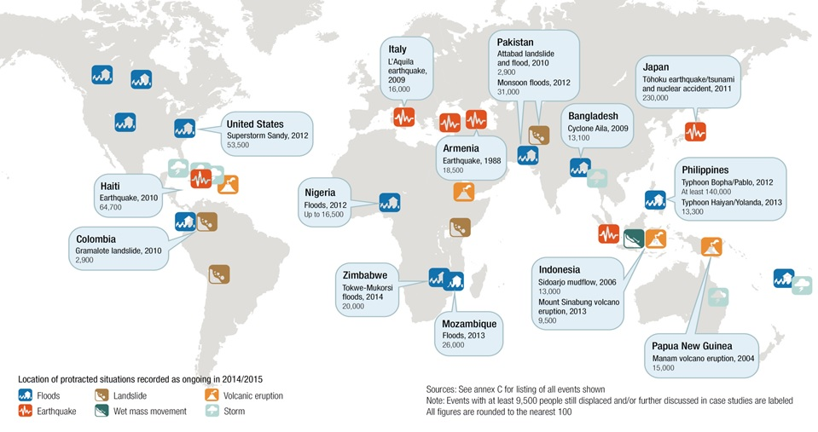
Weather-triggered disasters affect largely the coastal regions, countries lying below sea-level or storms-vulnerable areas. Proofs can be found mostly in East Asia, South Asia and Pacific, which are generally the most assailable areas suffering from typhoons, monsoon rains and floods, earthquakes, tsunamis and volcanic eruptions, but also from droughts, especially in case of Afghanistan or Sub-Saharan Africa.

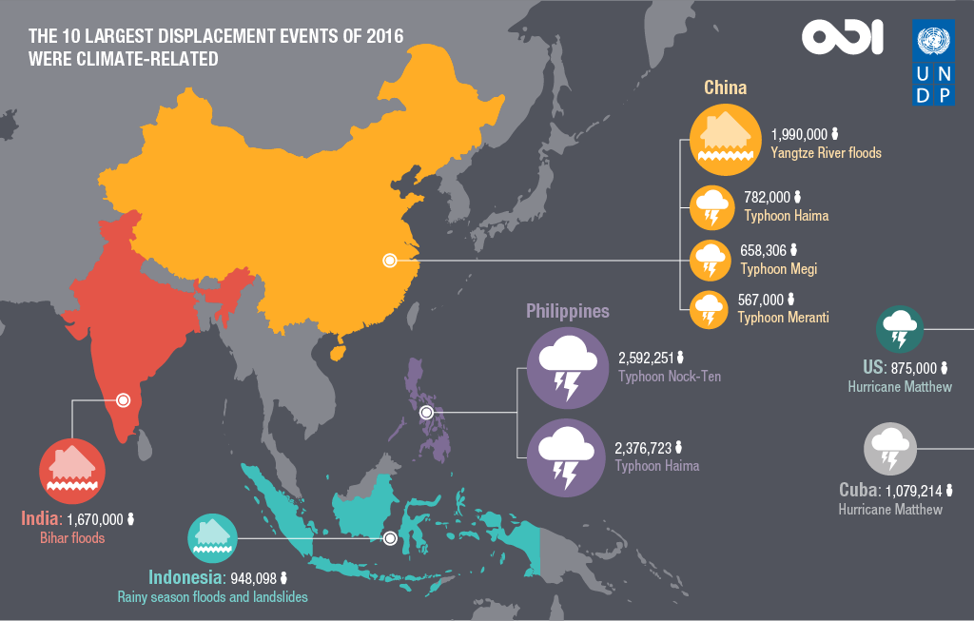
Asia and its densely populated cities of large mega-deltas on the coastline face high exposure to sea-level rise, storm surges and river flooding. As coastal cities expand through accelerating urbanization, many of the most vulnerable people settle in hazard-prone areas on the margins of cities and become increasingly exposed to disasters. Climate change threatens urban and rural livelihoods and settlements through increased river and sea flooding, which damages infrastructure, and saltwater intrusion into low-lying cropland causes considerable damage to crops.

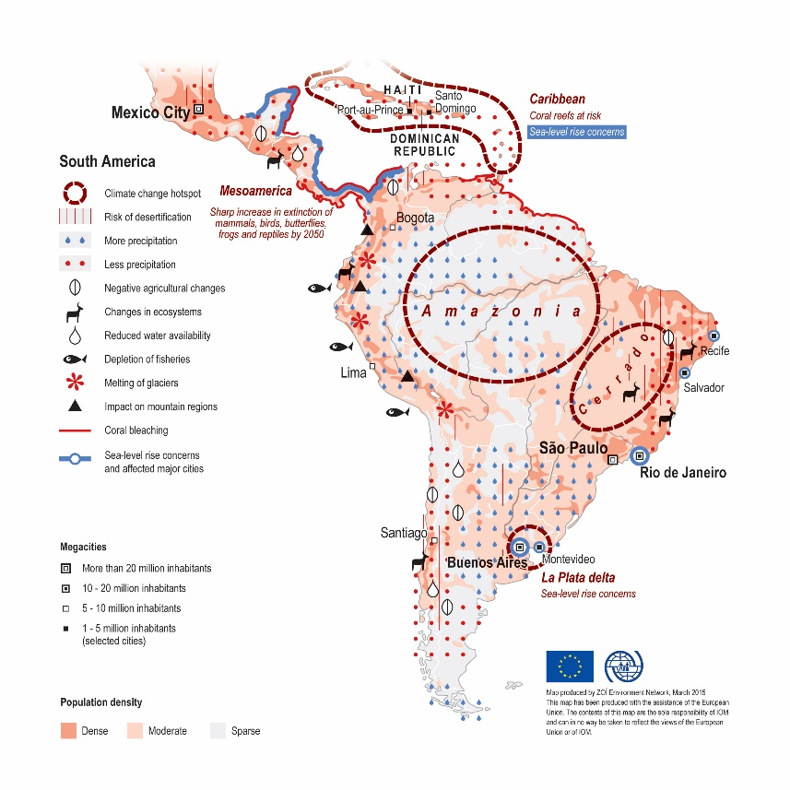
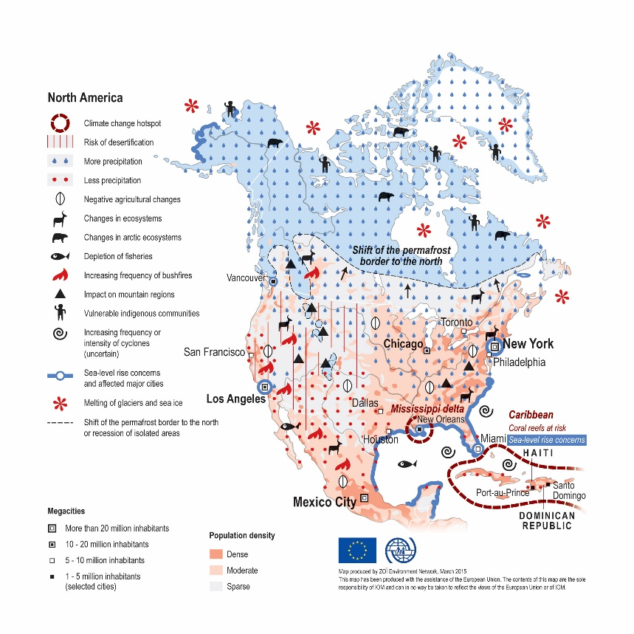
In America, change of precipitation, together with varying trends in annual shifts lead to water-related disasters such as floods, but also droughts with consequent wildfire danger. North America, in particular, faces more heat-waves in its urban centres causing wildfires associated with higher temperatures and lower rainfall. Coastal regions are also under threat from rising sea levels, together with intensifying tropical storm formation, that poses additional perils to densely populated continental coastal areas and small islands of the Caribbean region.

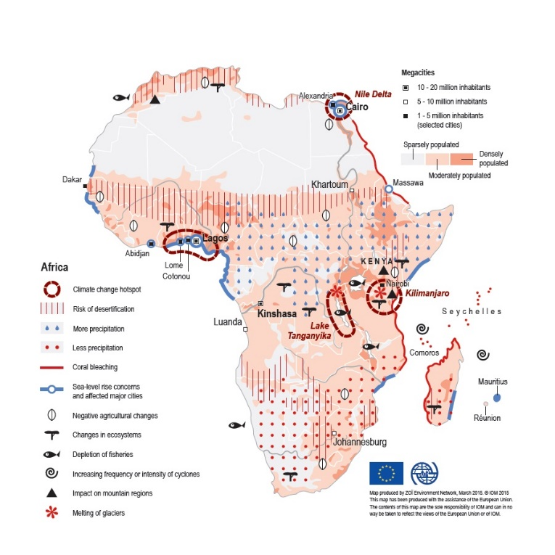
In Africa, the climate change challenges food and water security and thus endangers lives and livelihoods. As precipitation patterns shift, yields from rain-fed agriculture fall and compounded stress on water resources is foreseen to be intensified with escalated risks of flooding, drought and desertification.

Effects of climate change

Some of the environmental effects caused by the changing climate were already mentioned above, such as more common natural disasters in a form of floods, cyclones, earthquakes, tsunamis or droughts contributing to the increased occurrence of wildfires, etc. These, so called, sudden-onset events often destroy lives, homes and livelihoods – they bring along sudden devastation of communities, countryside and confidence.
But climate change has its slow-onset effects too. They can occur as rising sea-levels, degradation of freshwater resources, erosion and desertification. Persistent effects such as parched land, acidification of the oceans or glacial retreat have devastating impacts on entire ecosystems and peoples’ ways of living.
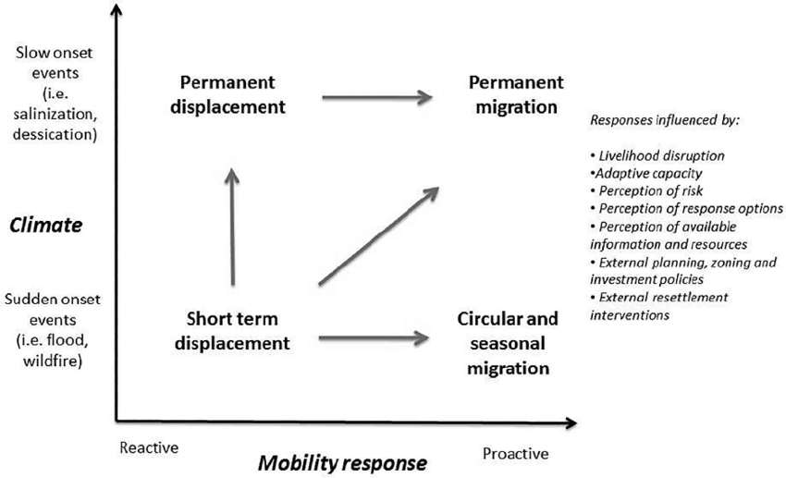

Food insecurity
Food security is about adequate access to food, which can be acquired through trade as well as production. Production self-sufficiency is not a prerequisite for food security - most food secure individuals buy the food instead of growing it, and even wealthy countries import some basic consumption commodities. But if the households and countries that stand to lose food production due to climate change are also those that depend most on agriculture and have fewest alternative sources of income, then falling harvests will certainly undermine household and national food security. Many developing countries already experience sizeable cereal gaps every year.
For example, one climate sensitivity analysis of African agriculture concludes that three countries – Chad, Niger and Zambia – will lose „practically their entire farming sector“ by the year 2100.
Understanding the full range of climate change impacts on food security therefore requires understanding the implications for prices, incomes and trade, as well as on production.
However, global food supplies are expected to be “relatively unaffected” by the climate-change. Global warming is projected to assure that a northward shift in thermal regimes will open up large tracts of potentially fertile land in the higher latitudes that are presently too cold, and have growing seasons that are too short for extensive crop cultivation. The higher surpluses in much of the northern hemisphere offset deepening deficits in parts of the south. Overall, the world is expected to gain some 9 per cent of cropland by 2080, almost all of it located in the northern hemisphere.
Relocation
Large-scale population displacement might be in future the only option to save the citizens of many, but mostly island nations that are facing the threat of rising sea levels. For example, the government of Caribbean nations already had to buy some lands in Fiji in order to relocate there their citizens if necessary.
However, such a relocation can bring the citizens to the very vulnerable position in which they will be seen as immigrants living in a foreign country, not being able to vote or participate at the fundamental political processes. The risk of losing national identity or the threat of rising xenophobic tendencies are also in place.
Furthermore, large population movements are already recognized by the UN Security Council as constituting a potential threat to international peace and security, particularly if there are existing ethnic and social tensions. Relocation of big groups of people will presumably redraw the ethnic map of many countries, bringing previously separate groups into close proximity with each other and in competition for the same resources. In the context of poor governance, poverty and easy access to small arms these situations can easily turn violent.

Internal vs Cross-Border displacement

Most disaster displacement linked to natural hazards and the impacts of climate change is internal, with those affected remaining within their national borders. However, human factors such as population density, poverty, bad governance, or discrimination, they all contribute to whether people affected by adverse effects of climate change will be able to stay within the borders of their State or have to flee abroad.
In all cases, people displaced by disasters have needs and vulnerabilities that must be addressed. People already displaced for reasons other than disasters linked to natural hazards – including refugees, stateless people, and the internally displaced – often reside in climate change ‘hotspots’ and may be exposed to secondary displacement. Moreover, similar impacts on their home areas can inhibit their ability to safely return.
Difference between an internally displaced person and a refugee
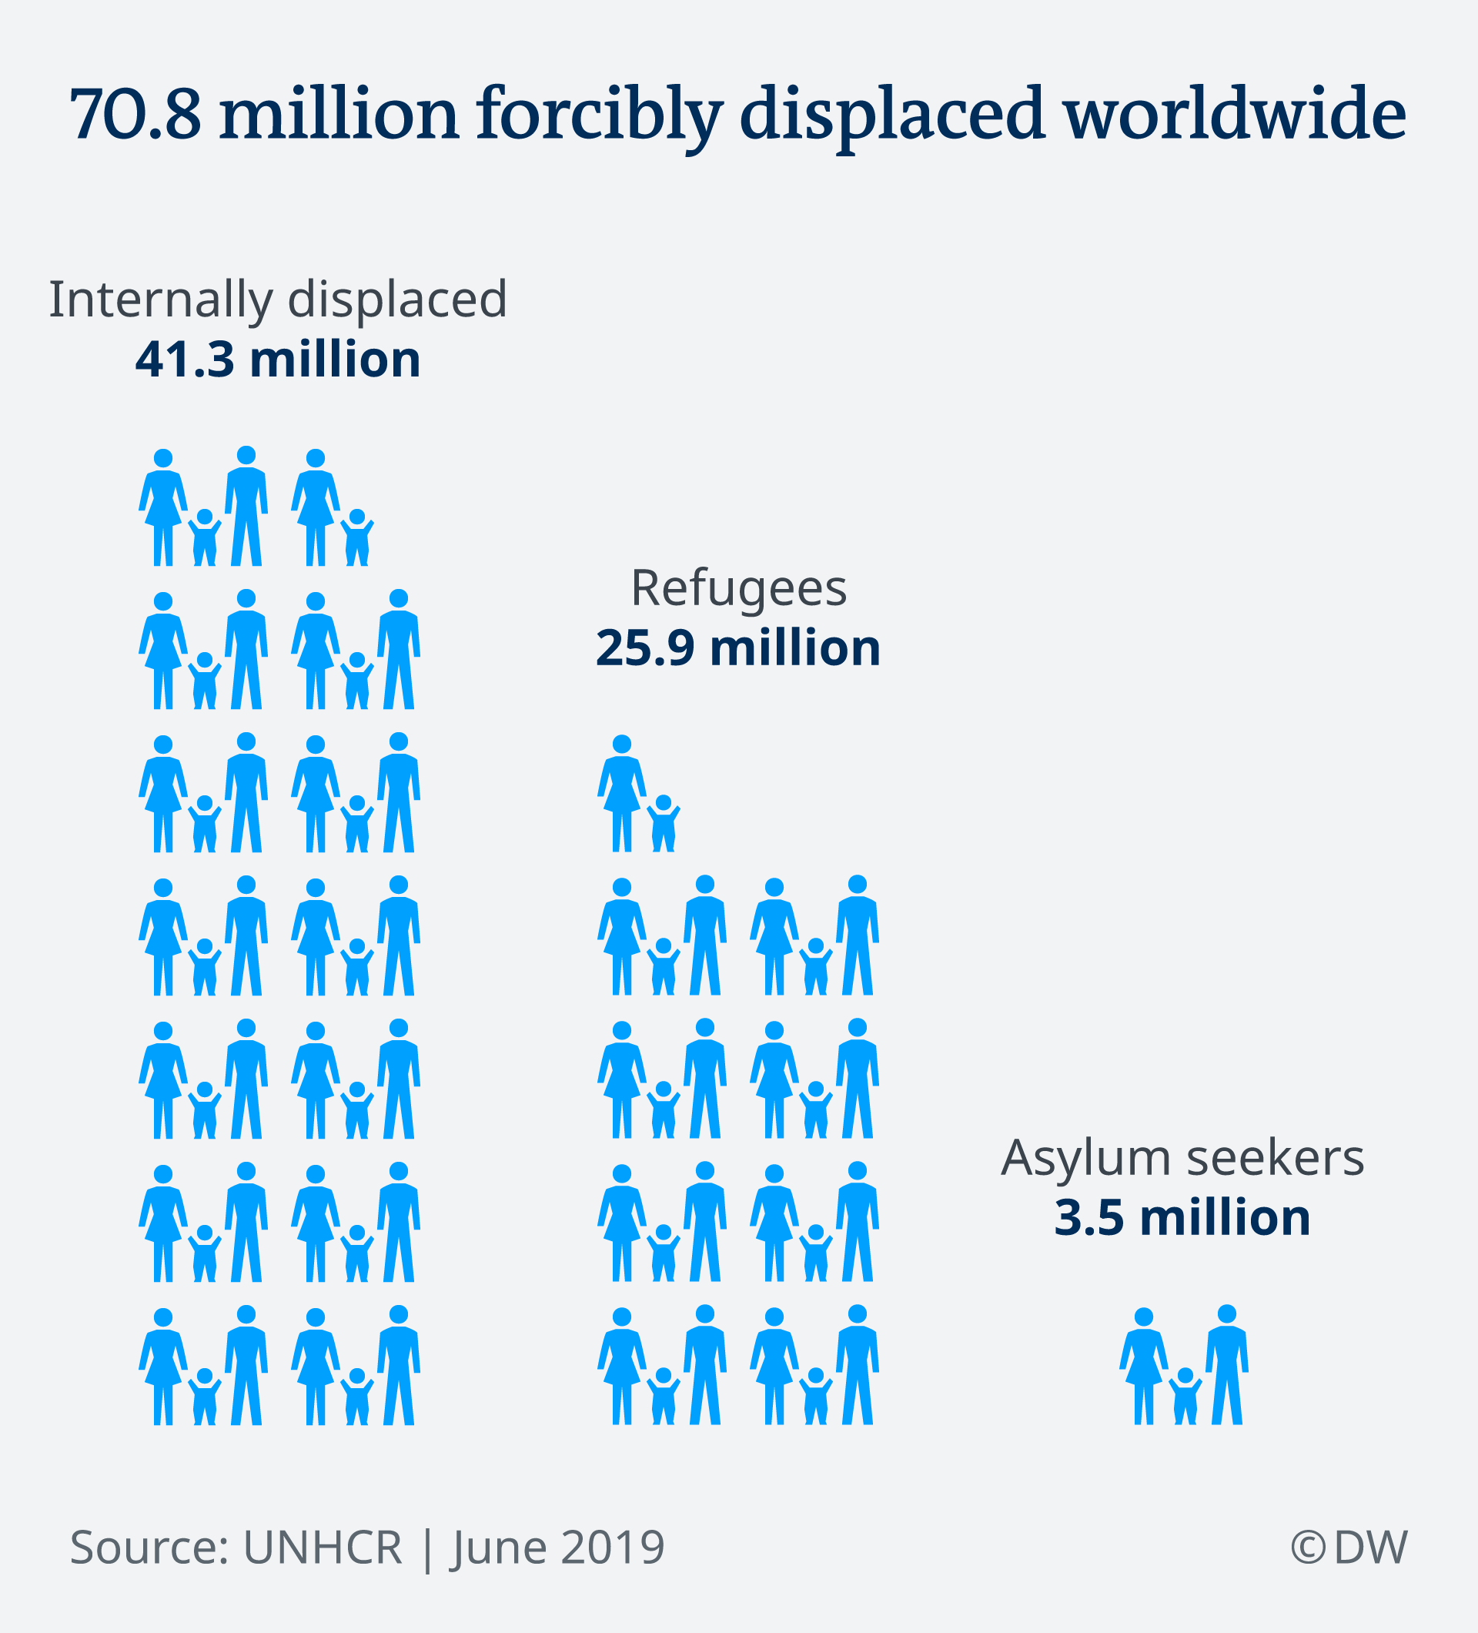
The 1951 Convention on the Status of Refugees is the only globally recognized legal definition of a refugee. People crossing their country´s borders as a result of severe disaster or climate-based occurrences are, however, not covered in this definition and therefore, protection and assistance for those displaced becomes increasingly uncertain and they have to undergo very difficult and long-running administrative processes to obtain a legal refugee status or asylum seeker status. It is, thus, important to understand that the commonly used term “climate refugee” does not legally exist.
Just as these “climate refugees”, internally displaced people do not have a special status in international law with rights specific to their situation either. The term "internally displaced person" is merely descriptive.
However, the rights to life, safety or health suggest that countries have a general obligation to protect people under their jurisdiction from adverse effects of climate change by reducing their vulnerability through climate change adaptation- and disaster risk reduction-measures and in particular strengthening the resilience of particularly vulnerable people and communities through development efforts.
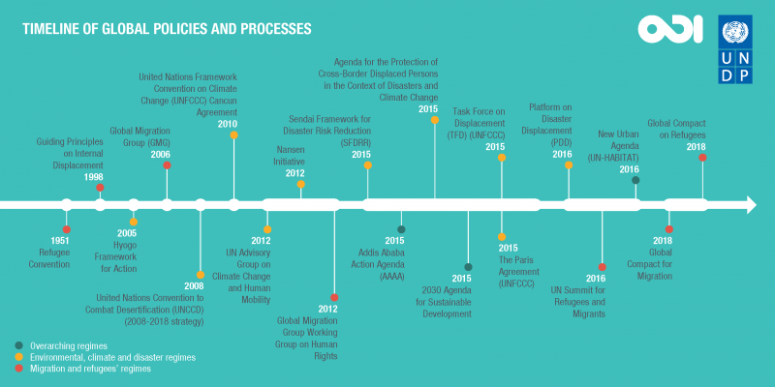
Past action

The Nansen Initiative aims to build consensus among States on key principles and elements to protect people displaced across borders in the context of disasters caused by natural hazards, including those linked to climate change. It was launched by the governements of Switzerland and Norway and the outcome of their collaboration is the Protection Agenda, endorsed by 109 States in 2015, marking the end of the Nansen Initiative.
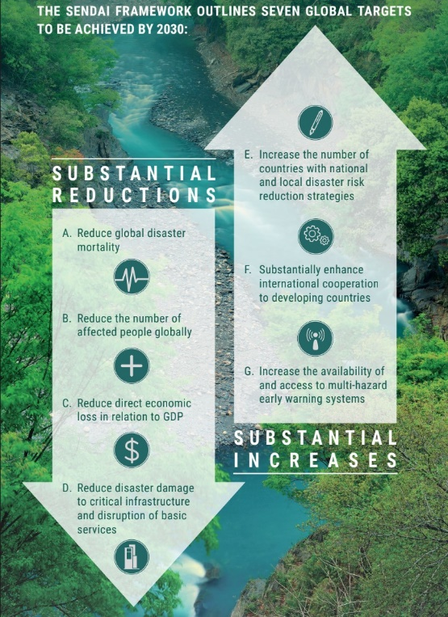
The Sendai Framework for Disaster Risk Reduction 2015-2030 - it was the first major agreement of the post-2015 development agenda and provides Member States with concrete actions to protect development gains from the risk of disaster. This Framework works hand in hand with the other 2030 Agenda agreements, including also The Paris Agreement on Climate Change.
The Paris Agreement is an agreement between nearly 200 countries, which aims to tackle climate change and also specifically refers to migration and human mobility due to climate change, calling for States to respect and promote the rights of those migrants.
Platform on Disaster Displacement has for the main objective to follow-up on the work started by the Nansen Initiative, and to implement the recommendations of the Nansen Initiative Protection Agenda.
New York Declaration for Refugees and Migrants was adopted on 19 September 2016 during the 71st session of the General Assembly, and formally acknowledged the importance of migration, environment and climate change issues. The Declaration recognized that climate and environmental factors were significant drivers of forced and voluntary migration and also noted that the impacts of migration movements on the environment should not be ignored.

Leading questions

Here are some questions that might help you with preparation of your Position Paper or Draft Resolution. The issues these questions are addressing shall be also a crucial part of Committee discussions, as their answering can contribute significantly towards writing a good Resolution adopted by all the Member States.
- What can UNHRC do to promote the rights of refugees and migrants displaced due to climate change and how can we ensure their protection?
- How the States should prepare for natural disasters and extreme weather events?
- Can protection measures affect national governments and their interests? How?
- What strategies have been implemented in the areas most affected by the climate change? Are they sufficient?
- How can we guarantee the human rights of both relocated persons and receiving communities?
- How can we use existing legal frameworks to ensure protection to the persons displaced as a result of climate change or natural disaster?
- How can we prevent conflicts in areas experiencing the effects of climate change and natural disaster?

Useful video links

https://www.youtube.com/watch?v=5xuZT7VkjVg
https://www.youtube.com/watch?v=a2nTq67So3U
https://www.youtube.com/watch?v=b6QEDbI5zrg
https://www.youtube.com/watch?v=WJd6LqzYye8
https://www.youtube.com/watch?v=vdeyz_1gNSA
https://www.youtube.com/watch?v=m4DlqdJRq40

Bibliography

https://www.ohchr.org/EN/HRBodies/HRC/Pages/AboutCouncil.aspx
https://www.worldbank.org/en/topic/fragilityconflictviolence/brief/forced-displacement-a-growing-global-crisis-faqs
https://www.ohchr.org/EN/Issues/HRAndClimateChange/Pages/HRClimateChangeAndMigration.aspx
https://environmentalmigration.iom.int/maps
https://www.rescue.org/displaced-season-2/climate-change-climate-change-displacement-happening-now
https://www.unhcr.org/climate-change-and-disasters.html
https://www.odi.org/opinion/10470-infographics-climate-change-migration-and-displacement
https://migrationdataportal.org/themes/environmental_migration
https://opendocs.ids.ac.uk/opendocs/bitstream/handle/20.500.12413/8545/IDSB_35_3_10.1111-j.1759-5436.2004.tb00130.x.pdf?sequence=1
https://www.unhcr.org/excom/excomrep/57ed16847/beyond-nansen-initiative-protection-agenda.html
https://disasterdisplacement.org/
https://news.un.org/en/story/2019/07/1043551
https://www.unhcr.org/new-york-declaration-for-refugees-and-migrants.html
https://environmentalmigration.iom.int/taking-stock-environmental-dimensions-gcm-negotiations#_ftn3

OHCRC Welcome to the Human Rights Council – Human Rights Council information booklet.
Lonergan, S., 1998, “The role of environmental degradation in population displacement”, Environmental Change and Security Project Report, Issue 4 (Spring 1998): 5.
Open-Letter from the UN High Commissioner for Human Rights to Member States on priorities for human rights-based climate action at the 25th Conference of the Parties to the Uniten Nations Framework Convention on Climate Change
Global report on Internal Displacement 2019
Mendelsohn et al. 2000: 6.
Parry et al. 1999: S51.
Stephen Devereux and Jenny Edwards -Climate Change and Food Security.
Sindico, F., 2005, “Ex-post and ex-ante [Legal] approaches to climate change – threats to the international community” New Zealand Journal of Environmental Law, Vol. 9: 209-238.
Oli Brown, 2008, “Migration and Climate Change“ International Organization for Migrtion Geneva, p.33.
https://www.unhcr.org/climate-change-and-disasters.html
Mr. Walter Kaelin, Envoy of the Chair of the Platform on Disaster Displacement
United Nations Office for Disaster Risk Reduction
Environmental Migration and the Global Compact for Safe, Orderly and Regular Migration (GCM) -From the New York Declaration to the GCM Zero Draft - An analysis during the GCM negotiations, as of 08 February 2018

