United Nations Social, Humanitarian and Cultural Committee (GA3) | Study Guide
Addressing the ethics and monitoring the development of human enhancement through genetic engineering and biotechnology |  | Alexandra Janasová & Lenka Rajňáková

Content
Chairs letter 3
Introduction to the committee 4
Introduction to the topic 5
Genetic engineering and biotechnology 6
History 6
CRISPR/Cas9 7
Human genetic engineering 8
He Jiankui affair 9
Key issues 10
Countries involved 12
Questions to answer in our committee 13
Relevant documents 15
Sources 15

Chairs letter

Most esteemed delegates,

It is our utmost pleasure to welcome you all to the 8th session of Zamun conference, held in the city of Žilina. As your chair and under-chair, we would like to congratulate you on having chosen the Social, Humanitarian and Cultural Committee, also known as the General Assembly 3rd Committee. We will do our best to make this conference unforgettable academic, as well as social and cultural experience for you.
First of all, we would like to introduce ourselves. We are students of Bilingual Secondary- Grammar school in Žilina, currently attending the 4th grade. Hopefully, our participation at MUN conferences in countries such as Hungary, Sweden, Luxembourg, Poland and others will be beneficial not only for us as the chairs, but most importantly for you- the delegates. We will help you to understand our topic and explain the rules of procedure, in case of misunderstandings.
Addressing the ethics and monitoring the development of human enhancement through genetic engineering and biotechnology is the topic we will be dealing with during the sessions of our committee. We believe that in today´s world, technologies are creating an inseparable part of our lives. They are not only facilitating numerous situations in the daily life, but also they have immense impact on the improvements in the scientific research. But unfortunately, this brings the pressing issues we need to face, one of them being the topic of our following discussions.
In order to help you with your research, we prepared this very detailed and informative study guide for you, therefore we recommend you to read it carefully. We hope to see each of you involved and passionate during our sessions. But remember, Zamun is not only about fruitful debates. During three days, you have a possibility to attend a variety of social activities where you will meet new people from around the world, you will experience new cultures and lifestyles. Enjoy it!
We very much look forward to meeting you all,

Your chair and under chair,
Alexandra Janasová & Lenka Rajňáková

Introduction to the committee

Social, Humanitarian and Cultural Committee (SOCHUM)
Being one of the six main committees at the General Assembly of the United Nations, SOCHUM is known also as The Third Committee of the General Assembly. The important topics relating to a range of social, humanitarian affairs and human right issues are allocated to the 3rd committee by the General Assembly.
The Committee discusses questions relating to the advancement of women, the protection of children, indigenous issues, the treatment of refugees, the promotion of fundamental freedoms through the elimination of racism and racial discrimination, and the right to self- determination. The Committee also addresses important social development questions such as issues related to youth, family, ageing, persons with disabilities, crime prevention, criminal justice, and international drug control.
The majority of agenda items of the Third Committee are similar to those of the Human Rights Council. The Committee will hear and interact with special rapporteurs, independent experts, and chairs of working groups as mandated by the Human Rights Council. Also interactive dialogues with the High Commissioner for Human Rights and the High Commissioner for Refugees are hosted by the 3rd committee each year.
Currently, the Social, Humanitarian and Cultural Committee is at its 74th session which is chaired by H.E. Christian Braun from Luxembourg.

Introduction to the topic

Genetic engineering is a multistage process consisting of manipulation, modification and recombination of an organism´s genes using biotechnology. It all started in 1970s, aiming to produce organism with improved characteristics by utilising the genetic modification of plants and animals. This process used to be extremely expensive and complicated at the beginnings, but intense progress in biotechnologies made it more affordable and popular. Nowadays, there are crop plants resistant to lower temperatures, herbicides, and insect attack, as well as tomatoes with a longer shelf life, all due to genetic engineering.
However, genetic engineering is a controversial theme when it comes to the question of allowing the alternation of genetic structure of human beings. Numerous deadly diseases and genetic mutations that human suffer from could be defeated and tackled by genetic engineering. Biotechnologies would help cure diseases and illnesses in unborn children, such as Down´s syndrome. But there are many ethic objections, when considering religious, social and even scientific point of view.
The pressure from certain groups which are strictly against genetic engineering caused that many people are scared of this technology. There are strong concerns about altering traits such as intelligence and beauty, and therefore creating designer babies. But, is this concern sufficiently founded to merit a prohibition on future modification work which would subsequently provide curing of variety types of diseases?
Genetic engineering is pushing society to re-evaluate ethical boundaries, as well as many significant academic and policy discussions are held concerning this issue. The aim of our committee is to determine the attitude towards the genetic engineering and biotechnology. We should ensure monitoring the development of human enhancement through this technology, keeping in mind it might be misused in the future.

Genetic engineering and biotechnology

Genetic engineering is a multistage process consisting of manipulation, modification and recombination of an organism´s genes using biotechnology. It is a set of technologies used to change the genetic makeup of cells, including the transfer of genes within and across species boundaries to produce improved or novel organisms. New DNA is obtained by either isolating and copying the genetic material of interest using recombinant DNA methods or by artificially synthesising the DNA. An organism that is generated through genetic engineering is considered to be genetically modified (GM) and the resulting entity is a genetically modified organism (GMO).

History

Since the first civilisations were established, humans have always tended to improve the organisms around them. They wanted more resistant crop plants with better taste or there were the attempts to domesticate the animals. Therefore, the indirect manipulation with genomes by controlling breeding and selecting offspring with desired traits is a traditional process practised for decades.
The history of genetics dates from the classical era with contributions by Pythagoras, Hippocrates, Aristotle, Epicurus, and others. We consider Gregor Johann Mendel as the Father of Genetics, although his work was not appreciated until after his death. Mendel's pea plant experiments conducted between 1856 and 1863 established many of the rules of heredity, now referred to as the laws of Mendelian inheritance.
In the 1940s and early 1950s, experiments pointed to DNA as the portion of chromosomes (and perhaps other nucleoproteins) that held genes. A focus on new model organisms such as viruses and bacteria, along with the discovery of the double helical structure of DNA in 1953, marked the transition to the era of molecular genetics.
The first artificial genetic modification accomplished using biotechnology was transgenesis, the process of transferring genes from one organism to another, was first accomplished by Herbert Boyer and Stanley Cohen in 1972. It was the result of a series of advancements in techniques that allowed the direct modification of the genome. In 1973, the first transgenic organism was made. It was when Herbert Boyer and Stanley Cohen cooperated on a project of inserting antibiotic resistance genes into the plasmid of an Escherichia coli bacterium. The first genetically modified animal was a mouse created in 1974. In 1976 the technology was commercialised, with the advent of genetically modified bacteria that produced somatostatin, followed by insulin in 1978. In 1983 an antibiotic resistant gene was inserted into tobacco, leading to the first genetically engineered plant. The first genetically modified food was the Flavr Savr tomato marketed in 1994. By 2010, 29 countries had planted commercialized biotech crops. In 2000 a paper published in Science introduced golden rice, the first food developed with increased nutrient value.
Subsequently, the scientists achieved a considerable progress in the field of genetic engineering and biotechnology. Genetically engineered human insulin, genetically modified organism, first synthetic genome are just the examples of the immense progress. However, the biggest step forward was the development of CRISPR/cas9 system which enables to specifically alter the genome of almost any organism in easier and cheaper way than ever before.

CRISPR/Cas9

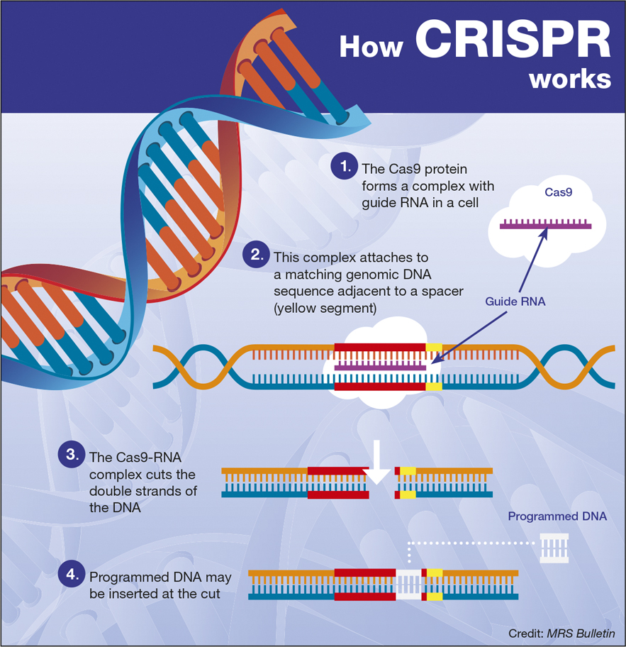
Img 1: https://www.cambridge.org/core/journals/mrs-bulletin/news/crispr-implications-for-materials-science
Devised in 2012, CRISPR/Cas9 represents one of the biggest technologies in gene editing which changed the world of biotechnology. CRISPR is a method that exploits Cas 9: a natural DNA-snipping enzyme in bacteria. The name of the technology is an abbreviation which stands for Clustered regularly interspaced short palindromic repeats. These are segments of DNA of a particular structure which are found widely in bacteria and archaea (prokaryotes). In short, CRISPR/Cas 9 technology is the process when Cas9 targets and edit particular genes. The target sequence of the DNA is recognized by a matching sequence on a “guide RNA” molecule carried alongside Cas9. This enables, for example, modified forms of the respective genes to be pasted into a genome. “In the wild, the CRISPR-Cas9 system is part of the prokaryotic immune system, which can snip out of the genome DNA acquired from foreign sources such as phages (bacterial viruses). The same molecular machinery is now being used to enable genetic material to be cut from and pasted into the genomes of other organisms, including eukaryotes such as humans. The method, and related approaches using other enzymes of the Cas family, could potentially supply a powerful way to cure diseases caused by mutations of one or a few specific genes, such as muscular dystrophy and thalassemia. A US clinical trial to assess the safety of CRISPR/Cas9 in a form of cancer therapy that enlists the body’s immune response to fight tumors has already received approval.”
Even though CRISPR is not the only technology used in the genome editing, it is revolutionary because it works very precisely and efficiently. Additionally, CRISPR is easy and cheap. Before, it used to take weeks or months in order to fiddle to alter a gene and it might have cost thousands of dollars. Now the gene editing might only take a few hours and so far the technology has worked on every organism it has been tried on.

Human genetic engineering

Human genetic diseases vary in many factors, one of them being the number of mutated genes. There are the diseases caused by a single gene mutation, such as sickle cell disease and muscular dystrophy. Treating of these single gene disorders is not a difficult process for the scientists. However, the majority of genetic diseases are affected by genetic variants in multiple genes while each gene has a different minor impact on the progression of disease. In that case, the process of genetic modification is more difficult and it requires more time.
After the invention of CRISPR, the modification of human genes became a controversial issue during many bioethical debates. The technology can correct various common deadly mutations in human embryos. However, there are two different ways of applying the genetic modification in humans: somatic gene modification and germline gene modification.
The gene modification of somatic cells is a technology used to edit disease-causing DNA within the body’s non reproductive cells. Therefore all the changes caused by genetic modifications are limited to the treated individual and would not be passed to their off springs. “Limiting the edits to these cells reduces the risk of having unintended, editing-related changes passed down to future generations. Researchers could harness this technology to potentially treat a multitude of genetic diseases.”
On the other hand, germline gene editing (GGE) creates changes that a person's descendants can inherit. This technology has a potential to cure a variety of genetically inherited mutations, however it causes many concerns, whether they are of technical, biological, moral or ethical character. According to Christopher Gyngell, Thomas Douglas & Julian Savulescu: “One common concern about GGE is that it will be used a tool of human enhancement and not merely to prevent disease. GGE has much greater capacity to be used as a means of enhancement than conventional selection methods. This is because it can target a large number of genes simultaneously and could be used to insert genes that would not occur naturally. While genetic selection allows selection within the normal human range, gene editing would allow the enhancement of human capacities to supranormal levels.”
Therefore, the germline gene editing can easily grow from curing deadly diseases to creating designer babies with physical and mental traits already chosen before they are born. This kind of human enhancement is even compared to eugenics, the theory aiming to improve the genetic quality of population, mostly known because of being practised in Nazi Germany.

He Jiankui affair

In 2018, twins Lulu and Nana were born being the first genetically edited babies ever. The genetic material was taken from a HIV-positive father and HIV-negative mother. Subsequently, twins had a gene CCR5 modified during embryonic development in an attempt to confer genetic resistance to HIV (when certain forms of HIV virus enters a host cell, CCR5 can act as a coreceptor).
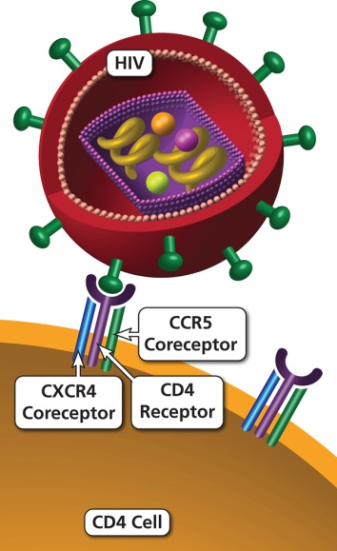

Img 2: https://aidsinfo.nih.gov/understanding-hiv-aids/glossary/112/ccr5
The project was conducted secretly at the Southern University of Science and Technology (SUSTech) in Shenzhen by He Jiankui and his two collaborators, Zhang Renli and Qin Jinzhou. The university stated their unawareness of this project. He Jiankui used CRISPR technology together with in vitro fertilisation. After MIT Technology Review exposed the story about the human experiment, it launched a worldwide wave of criticism. “Chinese authorities suspended all his research activities. He was immediately detained in SUSTech campus and kept under surveillance. On 30 December 2019, Chinese authorities announced that he was found guilty of forging documents and unethical conducts; he was sentenced to three years in prison with a fine of 3 million yuan. (US$430,000)”
“Between cells and babies lie embryos that are not intended for use in making babies—embryos that are intended only for research and will never be in a woman's uterus, but only in laboratory equipment. He's experiment was on an embryo that was intended to create a human.” And that is the biggest bioethics concern that triggered heated debates.

Key issues

Being already mentioned, germline genetic engineering has the positive aspect of curing diseases. Generations could be potentially saved from muscular dystrophy, blindness or even AIDS or cancer. But here are the main objections to pursuing the germline gene editing. The ethical, technological, moral, biological arguments are present and we should be aware that this issue is complicated as it pushes the society to re-evaluate ethical boundaries. All bearing in mind that the pressure from certain groups which are strictly against genetic engineering causes concerns within the population.
Here are the main arguments against germline gene editing:

Enhancement
This is the issue our committee should deal with and ensure the monitoring of enhancement through this technology. The designer babies with desired and chosen traits are a big social problem. There are the gaps between rich and poor, and enhancing humans genetically will create just another gap in the society between those who have and have not certain genetic improvements. “The risks here of creating greater inequalities seem to be obvious,” says Todd Daly, an associate professor of theology and ethics at Urbana Theological Seminary in Champaign, Ill. “And I’m not convinced that people who get these enhancements will want to make sure everyone else eventually gets them too, because people usually want to leverage the advantages they have.”
Bearing in mind that similar scenario is rather a future story, but this technology might be misused to create a super humans or a sort of conscious machines. Also altering an individual identity affects the human´s personal story, development and mental/physical capabilities. “There also is significant philosophical, ethical and religious opposition to transhumanism. Many thinkers from different disciplines and faith traditions worry that radical changes will lead to people who are no longer either physically or psychologically human.”
When using the biotechnology, there must be set a clear distinction between therapy and enhancement.
Ethical and moral aspect
Experiments and testing of this technology on human embryos are leading to pressing ethical and moral issue. When doing the research there is a high risk of harming the embryo. That can lead to the death of the embryo which is considered to be a morally weighty harm. Another ethical problem is that embryos used in genetic research are usually destroyed when the study is complete.
However, there is a special type of embryos with an extra set of chromosomes, called triploid embryos. These embryos cannot survive pregnancy, and are normally spontaneously aborted. There was an experiment done by Liang and co-authors trialling the CRISPR system in these embryos which had no chance of resulting in a live birth. Some people claim that this did not result in morally significant harm, but still there is a strong ethical concern whether we should test biotechnologies on any kind of human embryos.
“In general, research that is conducted in embryos could use viable or nonviable embryos leftover from IVF, or embryos created expressly for research. Each case has its own moral considerations.”
Safety/ off-target mutations
The unintended changes to the genome, so called “off-target” mutations, are creating the safety concerns in the field of germline gene editing. Therefore, in that case there is a risk of causing other diseases or disabilities different from the cured ones. For example, when the enzyme Cas9 accidentally cut genome that is similar to the targeted one, it may result in the tumor growth. However, every treatment and medicines has its side-effects or undesirable results for a certain amount of people. The question is if the technology is examined enough. Although, the biotechnologies are tested on the animal embryos and the ratio of off-target mutations is decreasing, there is a lack of experience in human cells. Experimenting with human germline gene editing is considered morally inacceptable in the majority of countries. Therefore, the question whether the application of this treatment is safety for humans is not clearly answered yet.
Autonomy of future generations
The germline gene editing is an irreversible process. When a gene is modified ones, the process cannot be done backwards. This would subsequently affect all the future generations when germline genes are edited.
“Another frequently heard objection against germ-line genetic engineering is that it would be uniquely hazardous because the changes it would bring are irreversible and would affect all generations to come. It would be highly irresponsible and arrogant of us to presume that we have the wisdom to make decisions about what should be the genetic constitutions of people living many generations hence.”

Countries involved

In May 2019, the United Nations report FRONTIER TECHNOLOGY QUARTERLY published an article called “Playing with genes: The good, the bad and the ugly”. It was an overview of ethical/moral aspects of genetic engineering and biotechnology and their impact on nations. In the section called Select country approaches to regulate genetic technologies were mentioned the countries opposed to biotechnologies. Here is an extract from this part: “Canada, strongly influenced by public outcry over the production by British scientists of a cloned sheep called “Dolly”, decided to ban and criminalize human cloning research in 2004. In Germany, the creation, use, and harvesting of embryonic cells for basic research are also prohibited. In France, the modification of the human genome may be undertaken for preventive, diagnostic or therapeutic purposes only. In the Republic of Korea, laws prohibit genetic experimentation with and modification of human embryos, including any product that alters genes…”
However, the table was published in the same document concerning countries taking an initiative in genetic research. Even though all these countries are not supporting the testing on embryos, they consider genetics and biotechnology as an important aspect of modern society.
In the table below, you can see the countries and objectives of their initiatives:
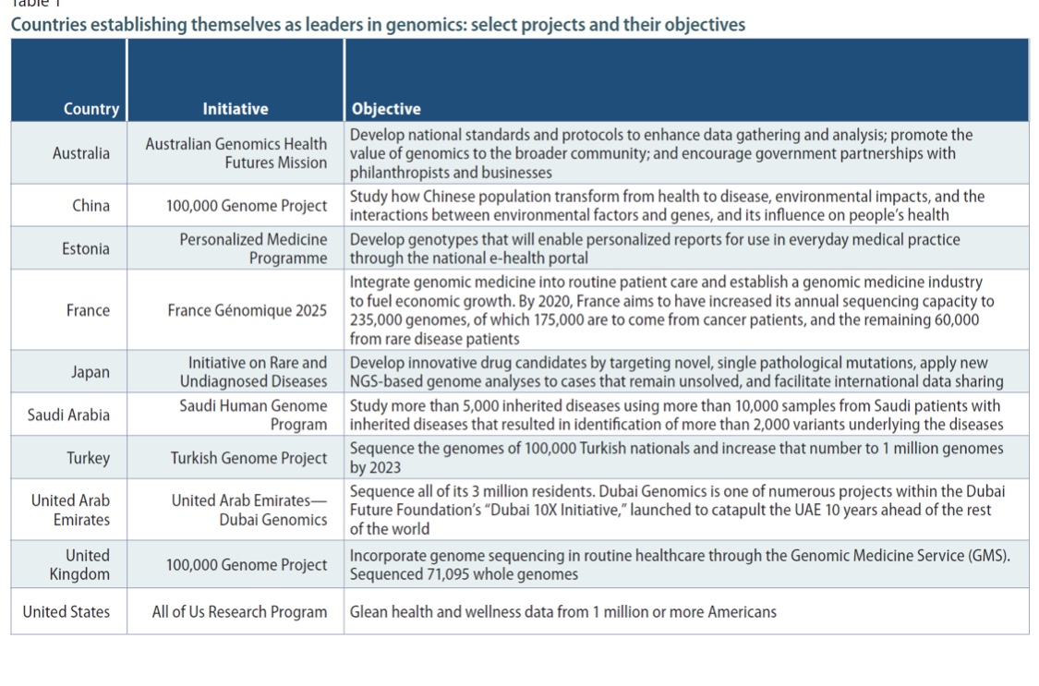
Table 1: https://www.un.org/development/desa/dpad/wp-content/uploads/sites/45/publication/FTQ_May_2019.pdf

Questions to answer in our committee

After reading all the positive and negative aspects of different forms of gene editing, you should carefully study the policy of your country concerning genetic engineering and biotechnology. Together in our committee, we should decide whether it is acceptable to do the research on human embryos, what are the potential benefits or risks inherent in conducting gene editing research. Which forms of gene editing may be potentially used in the future to cure serious diseases and how can the countries regulate and monitor the enhancement through this technology, all bearing in mind the ethical and cultural perspective of genetic engineering.

Here are some questions which might be useful during your research:
- How can our committee regulate and monitor the human enhancement through the genetic engineering?

- Is genetic engineering ethically acceptable?

- What is more valuable: curing deadly genetic diseases or guarding the autonomy of future generation?

- Are the biotechnologies safe enough?

- Which modifications (if any) should be promoted and which discouraged?

- Should the countries set a worldwide ban on human genetic engineering?

- Where is the red line that should not be crossed in human gene editing?

- Should the countries support the research aiming to cure genetic diseases?

- Which different types of research should be reviewed by regulatory authorities?

In case of any further inquiries, concerning the topic or the conference, feel free to contact us:
Alexandra Janasová- alexandrajanasova@gmail.com
Lenka Rajňáková- lenka.rajnakova0908774520@gmail.com

Relevant documents

- Declaration of Helsinki -originally adopted in June 1964
The World Medical Association has developed the Declaration of Helsinki as a statement of ethical principles to provide guidance to physicians and other participants in medical research involving human subjects. Medical research involving human subjects includes research on identifiable human material or identifiable data.
- The Universal Declaration on the Human Genome and Human Rights
The declaration was adopted unanimously and by acclamation at UNESCO's 29th General Conference on 11 November 1997. The following year, the United Nations General Assembly endorsed the Declaration. The Declaration has been cited in many academic and popular journals and has been referred to in numerous national and regional legislation on medicine, privacy and genetic research.
- Universal Declaration on Bioethics and Human Rights
It was in October 2005 that UNESCO adopted this declaration, after almost two years of negotiations. The declaration has many contributions to the world of biotechnologies, one of them was the definition of the term bioethics.

Sources
https://en.wikipedia.org/wiki/United_Nations_General_Assembly_Third_Committee#cite_note-Swiss_Guidebook-1
https://www.sciencedirect.com/topics/neuroscience/genetic-engineering
https://www.britannica.com/science/genetic-engineering
https://ghr.nlm.nih.gov/primer/genomicresearch/genomeediting
https://www.vox.com/2018/7/23/17594864/crispr-cas9-gene-editing
https://onlinelibrary.wiley.com/doi/pdf/10.1111/japp.12249
https://www.un.org/development/desa/dpad/wp-content/uploads/sites/45/publication/FTQ_May_2019.pdf
https://www.nap.edu/read/24623/chapter/8#138
https://www.businessinsider.com/what-countries-allow-researchers-to-edit-human-embryos-2015-10

^{1, 2}https://www.un.org/en/ga/third/
https://en.wikipedia.org/wiki/Genetic_engineering
https://www.cambridge.org/core/journals/mrs-bulletin/news/crispr-implications-for-materials-science
https://ncats.nih.gov/somatic
https://onlinelibrary.wiley.com/doi/pdf/10.1111/japp.12249
https://en.wikipedia.org/wiki/He_Jiankui_affair
https://academic.oup.com/jlb/article/6/1/111/5549624
https://www.pewresearch.org/science/2016/07/26/human-enhancement-the-scientific-and-ethical-dimensions-of-striving-for-perfection/
https://www.pewresearch.org/science/2016/07/26/human-enhancement-the-scientific-and-ethical-dimensions-of-striving-for-perfection/
https://www.genome.gov/about-genomics/policy-issues/Genome-Editing/ethical-concerns
https://iatranshumanisme.com/wp-content/uploads/2019/01/bostrom_2003-Human-Genetic-Enhancements-A-Transhumanist-Perspective.pdf
https://www.un.org/development/desa/dpad/wp-content/uploads/sites/45/publication/FTQ_May_2019.pdf
https://www.who.int/bulletin/archives/79(4)373.pdf
https://en.unesco.org/themes/ethics-science-and-technology/human-genome-and-human-rights

